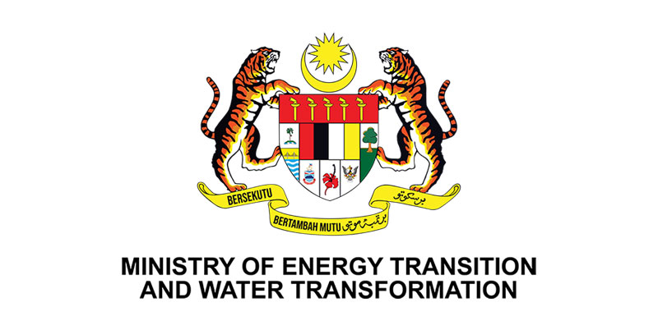
YAB Dato' Sri Haji Fadillah Bin Haji Yusof
Deputy Prime Minister of Malaysia II, Minister of Energy Transition & Water Transformation (PETRA)
KEYNOTE SPEECH
Clean Energy Transition Asia Summit at International Greentech & Eco Products Exhibition & Conference Malaysia (IGEM)
Date: 9 October 2024
Time: 2.45 PM
Location: Exhibition Hall 6A, Level 1, KLCC

Bismillahirrahmanirrahim,
(Salutations)
Assalamualaikum Warahmatullahi Wabarakatuh and Salam Malaysia Madani

- I am deeply honoured to address this distinguished audience at the Clean Energy Transition Asia (CETA) Summit, held in conjunction with the International Greentech & Eco Products Exhibition & Conference Malaysia (IGEM). It is a privilege to be among esteemed leaders from the public and private sectors, all of whom are playing a pivotal role in shaping the future of our energy landscape.

- As the Minister of Energy Transition and Water Transformation, I stand not only as a representative of the government but as a voice for the nation’s collective ambition towards a greener, more sustainable Malaysia. The commitment to reduce greenhouse gas emissions is not simply a policy directive – it is a national imperative. In alignment with our obligations under the Paris Agreement, Malaysia is committed to reducing emissions intensity by 45% by 2030, with a long-term vision of achieving net-zero emissions by 2050.

- The facts are undeniable. Our energy sector is responsible for nearly 80% of annual greenhouse gas emissions, amounting to approximately 259 million tonnes. This stark reality drives our mission. The transition to clean energy is not merely a strategic goal but a necessity that demands immediate and decisive action. We are at a crucial juncture, and it is our collective responsibility to ensure that the future we build is one of renewal, not decline.
- The road ahead will not be without challenges. We must address the complexities of the energy trilemma – balancing sustainability, energy security, and affordability. However, this is not a time for hesitation. It is a time for bold, coordinated efforts to secure a cleaner, more resilient energy future for Malaysia.

Ladies and Gentlemen,

MALAYSIA’S PURSUIT TOWARDS NET-ZERO EMISSIONS BY 2050
- Looking ahead, The Paris Agreement laid the groundwork for our fight against climate change, and from those foundational principles, we have forged pathways for meaningful action. In August 2023, we proudly launched our National Energy Transition Roadmap (NETR), a comprehensive strategy designed to transform our energy systems. This roadmap is our nation’s commitment to transition towards a lower carbon energy system, moving away from fossil fuels and embracing cleaner, sustainable energy alternatives.

- This transition will impact every sector of our economy, from electricity generation and transportation to industrial processes and energy consumed in our homes. Through NETR, we are addressing the climate crisis, securing our energy future, and building a resilient, sustainable nation for generations to come.

- For Malaysia, this transition is not just about cutting emissions; it’s about ensuring this shift is just and responsible. As a country historically reliant on fossil fuels, we must ensure that no one is left behind in this transformation. We owe it to our people to create new opportunities that strengthen, not weaken, the fabric of our society.

- With this in mind, I am proud to share Malaysia’s commitment to a brighter, more sustainable future. We are not merely planning for change; we are embracing it with action:

- We aim to increase the share of renewable energy in our national electricity mix to 40% by 2035 and 70% by 2050. Though ambitious, these targets are within reach through innovation and commitment. Currently, our renewable capacity stands at 28%, and technological advancements will be critical to our progress. To reach this target, we require private sector support and cooperation through shared innovation, green invention, and knowledge sharing.

- We are moving away from coal. Coal-fired generation will be gradually phased out, and no new coal power plants will be established. The International Energy Agency has clearly stated that reducing coal dependency is critical to limiting global warming, and we are acting on that premise.

- We will enhance grid flexibility by investing in smart grids, digitalisation, and energy storage systems. By 2035, we aim to increase grid flexibility by 20%, enabling greater integration of renewable energy sources.

- We aim to stimulate innovation, attract investments, and adapt our energy infrastructure to the demands of a rapidly evolving global landscape that increasingly focuses on ESG (Environmental, Social, and Governance) commitments. Therefore, we have introduced the Corporate Renewable Energy Scheme (CRESS) which encourages corporate consumers to invest and source renewable energy directly from solar producers through third-party grid access arrangements. The implementation of CRESS and its forthcoming guidelines reflects our steadfast commitment to grid liberalisation and our determination to foster a competitive, efficient, and resilient energy market in Malaysia.

- We are pushing for regional power grid integration to further support and enhanced energy security within member states. Further to that the regional integrated grid can as well be the economic catalyst in fostering regional cooperation through cross-border renewable energy trade. By sharing excess energy, we can reduce reliance on fossil fuels while building an integrated ASEAN energy infrastructure. Towards this end, we hope that the first green electricity delivery from our maiden cross-border renewable energy auction for Singapore energy importer under the auspices of Energy Exchange Malaysia shall commence before end of this year.

- These commitments reflect Malaysia’s determination in leading the change charge to create a more sustainable regional energy system and landscape. More importantly, this strategic intent embodies our desire to leave a legacy of hope. In the future, we envision our children and grandchildren to enjoy quality lifestyle, our economies will thrive on renewable resources, and our planet will continue to be the nurturing home it has always been, sustained by our commitment to sustainable development.

MALAYSIA’S CHAIRMANSHIP 2025 ASPIRATIONS:

- As Malaysia prepares to assume the ASEAN Chairmanship in 2025, we are presented with a significant opportunity to lead the region in advancing cross-border renewable energy trade. This is our moment to drive knowledge-sharing, advance policy innovations, and position Malaysia as a regional leader in the shift towards cleaner energy. We will demonstrate our unwavering commitment to sustainability and drive meaningful progress across ASEAN by leveraging our key industries, semiconductors, electric vehicles, and digitalisation.

- As global demand for green electricity rises, Malaysia stands poised to seize this opportunity. By capitalising on our robust renewable energy sector, we aim to attract foreign investments that will drive our nation’s green economy forward. To remain competitive, we must embrace this shift fully. Renewable energy integration across all sectors—from transportation to industry—will be crucial, and though the road may be difficult, the innovation and collaboration will pave the way for our sustainable future.

- Yet, we must not stop there. We need to make green electricity accessible to everyone. Whether through direct sourcing from renewable projects or other solutions, we must reduce our carbon footprint and increase our grid's share of clean energy.

- At this summit, I urge our government agencies and utility companies to work collaboratively to cut through the red tape and make it easier for businesses to lead in this vital space. Together, we can position Malaysia as a leader in the global energy transition, ensuring that our future is both competitive and sustainable.

CROSS COLLABORATION FROM ALL SECTORS
Ladies and Gentlemen,

- As leaders in the private sector, your influence on shaping Malaysia’s energy future is pivotal. I encourage you to engage in meaningful discussions on how we can collectively lead the ASEAN region in advancing clean energy initiatives.

- Our collaboration is essential to harmonising energy regulations, establishing a cohesive framework that enables smooth cross-border renewable energy trade. Such efforts will not only strengthen our energy security but also position our region as a global leader in sustainability.

- Let us explore the opportunities for strategic partnerships among governments, industry stakeholders, and ASEAN counterparts. By combining our resources and expertise, we can accelerate sustainable energy projects that drive investment and foster technological innovation. Now is the time to unite our efforts, creating solutions that meet today’s energy demands while paving the way for a resilient, sustainable future.

- As I conclude, I leave you with this thought: at this pivotal moment of energy transition, what legacy do we aim to leave for future generations? Will we be remembered as the architects of a sustainable future or as stewards of a world weighed down by the consequences of inaction? The decisions we make today will define the world our children inherit. Together, let us be the change-makers, the innovators, and the leaders who embrace the energy transition and inspire others to join us on this critical journey.

With that I thank you.

Wabillahit Taufiq Wal Hidayah, Wassalamu'alaikum Warahmatullahi Wabarakatuh

